ETCD Backup---------🡪

Lab

We have a working Kubernetes cluster with a set of web applications running. Let us first explore the setup.

How many deployments exist in the cluster in default namespace?

$ kubectl get deployment --namespace default

What is the version of ETCD running on the cluster?

Check the ETCD Pod or Process

$ kubectl describe pods etcd-controlplane --namespace=kube-system



Or ----

$ kubectl logs etcd-controlplane --namespace=kube-system | grep -i 'etcd-version'

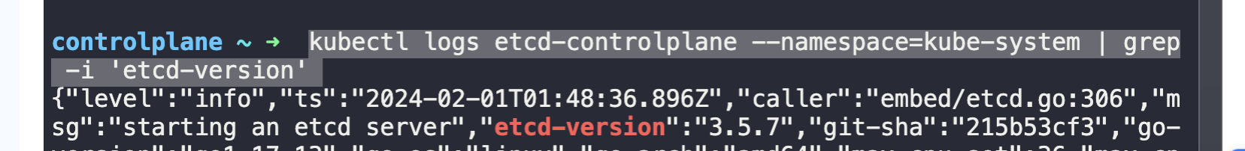

Where is the ETCD server certificate file located?



The master node in our cluster is planned for a regular maintenance reboot tonight. While we do not anticipate anything to go wrong, we are required to take the necessary backups. Take a snapshot of the **ETCD** database using the built-in **snapshot** functionality.

Store the backup file at location /opt/snapshot-pre-boot.db

ETCDCTL_API=3 etcdctl --endpoints=https://[127.0.0.1]:2379 \

> --cacert=/etc/kubernetes/pki/etcd/ca.crt \

> --cert=/etc/kubernetes/pki/etcd/server.crt \

> --key=/etc/kubernetes/pki/etcd/server.key \

> snapshot save /opt/snapshot-pre-boot.db

Luckily we took a backup. Restore the original state of the cluster using the backup file.

ETCDCTL_API=3 etcdctl --data-dir /var/lib/etcd-from-backup snapshot restore /opt/snapshot-pre-boot.db